Project Management

PROJECT MANAGEMENT
CROSS-UNIVERSITY MOBILE APP
CASE SCENARIO 3

Reference: Stakeholdermap.com templates

Project Management
CONTENTS
Front Page .................................................. 1
Contents .................................................. 2
PROJECT Initiation Document (PID) .................................................. 3
Stakeholders Analysis .................................................. 5
Power Interest Matrix .................................................. 7
Work Breakdown Structure (WBS) .................................................. 8
The two Questions .................................................. 9
Conclusion .................................................. 10
Bibliography .................................................. 11
APPENDIX 1 - Budget .................................................. 12
APPENDIX 2 - Technical Requirements .................................................. 13

Project Management
PROJECT INITIATION DOCUMENT (PID)
PROJECT TITLE: Roehampton Cross-University Mobile App for London Universities
PROJECT START DATE: ¹st September 2025 PROJECT END DATE: ³¹st August 2026
BUDGET INFORMATION:
- Project Management - £0 (Covered by existing SU staff)
- University Representatives - £0 (In-kind contribution from participating universities)
- Student Focus Groups - £2,500 (Refreshments and incentives)
- Marketing Materials - £3,500 (Design and production)
- Launch Events - £5,000 (Across participating universities)
- Student Ambassador Program - £4,000 (Training and incentives)
- Technical Integration Support - £3,000 (Specialist consultancy if needed)
- App Development - £0 (Provided by EE as sponsorship)
- User Testing - £2,000 (Equipment and incentives)
- Contingency - £2,550 (15% of total costs)
- Total - £22,550 ()
Project Manager: Roehampton Student Union President
Contact Details: rus@roehampton.ac.uk | 020 8392 3321
Project Objectives:
The National Union of Students seeks to establish a platform and opportunity for cross-university interaction on for social activity, clubs, and societies for universities throughout London with the goal of implementing it nationwide, to maximize opportunities for all students, address diversity issues, and support/promote inclusion policies. Every university in London has committed to contributing funds and resources in proportion to the number of students enrolled to assist in the development of a new mobile application that will offer daily information about all events hosted by university clubs and societies, links to contact information, and the ability for students to promote their own events.

APPROACH:
- Make a schedule that includes all personnel information and the agenda in order to improve time utilization
- Call a meeting to establish project governance and discuss the procedure with representatives from the student unions at each of the participating London institutions
- To find best practices and possible integration points, investigate and analyze the platforms currently used for university events
- Collect needs and preferences for the mobile app by doing focus groups with students from various colleges
- In conjunction with the EE development team, create comprehensive technical requirements
- To test with student representatives, develop prototypes of the user experience
- Create privacy guidelines and procedures for data sharing that adhere to the university regulations and GDPR
- Provide a staged implementation strategy with distinct deliverables and milestones
- Create a thorough testing plan that incorporates students from several colleges
- Develop communication and marketing strategies for the app’s debut at each partner university
Reference: Schwalbe, K., IT Project Management, 2015

Project Management
STAKEHOLDERS ANALYSIS
Stakeholder | Organisation | Impact | Influence | Contribution | Tactics to engage with Stakeholders
Roehampton Student Union | Roehampton University | High | High | Leading the project, providing project management resources, coordinating with other universities | Regular project status meetings, email updates, dedicated project portal for document sharing and collaboration
Other London Universities Student Unions | Various London Universities | High | High | Providing resources proportionate to enrollment numbers, representing their students interests, facilitating access to their university clubs and societies | Monthly steering committee meetings, bi-weekly email updates, dedicated representatives in project team, collaborative workshops
EE Development Team | EE | High | High | Providing technical expertise and resources to build the app, advising on technical feasibility | Weekly development meetings, technical specification documents, regular demos and feedback sessions, clear communication channels for technical queries
University Students | London Universities | High | Medium | End users of the app, providing feedback during testing phases, early adopters | Focus groups, surveys, user testing sessions, social media engagement, student ambassadors program
Student Clubs and Societies | London Universities | High | Medium | Content providers for the app, event organizers, key users | Training sessions, content creation workshops, early access to beta versions, dedicated support channels
Roehampton Vice Chancellor | Roehampton University | Medium | High | Project sponsor, providing institutional support, interested in publicity | Monthly executive briefings, press release opportunities, invitation to key milestone events
Other Universities Senior Management | Various London Universities | Medium | Medium | Institutional support, potential resource allocation | Quarterly briefings, formal communications through proper channels, invitation to major milestone events
EE Director (Former Roehampton Student) | EE | Medium | High | Champion within EE, facilitating corporate support | Personal updates, recognition in project communications, invitation to key events
IT Support Staff | Participating Universities | Medium | Medium | Technical support for integration with university systems, advice on data protection | Technical working groups, documentation sharing, training sessions
National Union of Students | NUS | Medium | Medium | Strategic guidance, potential support for national rollout | Strategic planning sessions, progress reports, consultation on national expansion
University Marketing Departments | Participating Universities | Medium | Low | Promotion of the app within their institutions | Marketing strategy sessions, brand guidelines, promotional material templates
Student Parents/Guardians | N/A | Low | Low | Indirect stakeholders with interest in student activities | Information through university communication channels, FAQs about data privacy and security
Reference: CIO Wiki - Stakeholder, 2020

Project Management
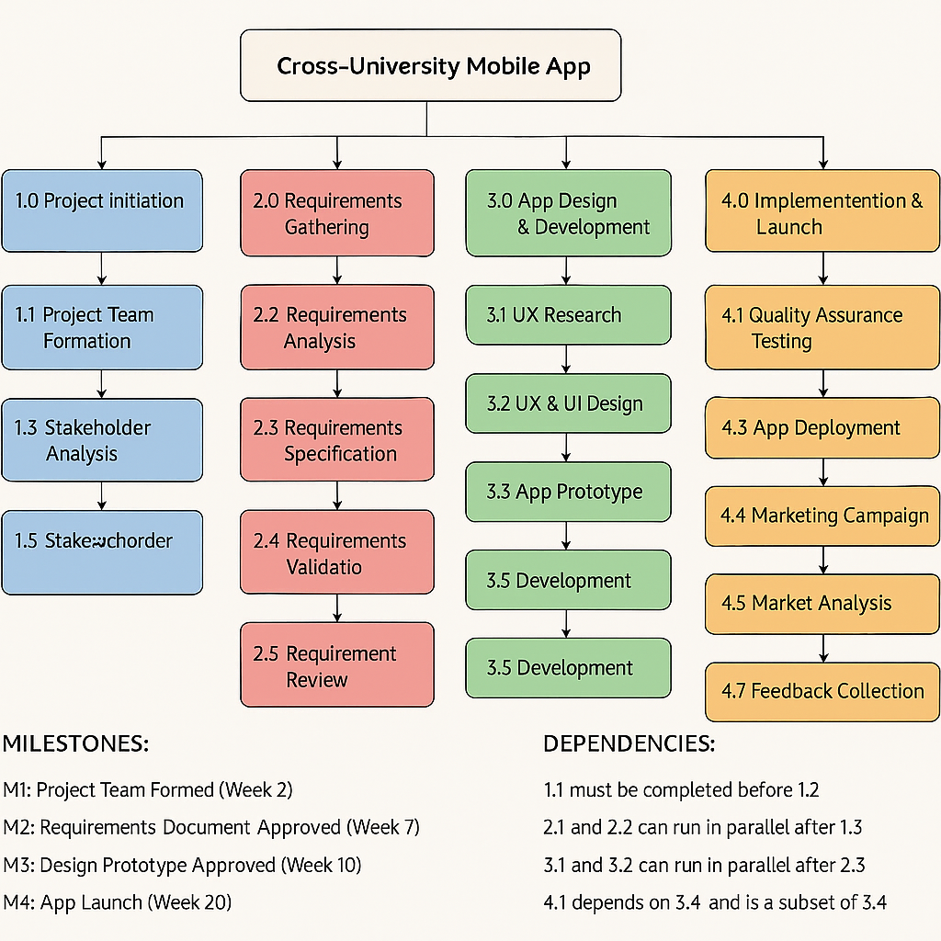
WORK BREAKDOWN STRUCTURE (WBS)

Project Initiation (blue), requirements gathering (red), app design and development (green) and implementation and launch (orange) are the four main phases of the Cross-University Mobile app project’s Work Breakdown structure (WBS), which provides a thorough hierarchical breakdown of the entire project scope. With project initiation covering team formation and stakeholder analysis, requirements gathering moving forward through analysis, specification, validation and review, app design and development following a logical sequence from UX research through design, prototyping and development and implementation and launch covering testing, deployment, marketing and feedback collection, each phase is systematically divided into work packages. Four crucial turning points are identified in the diagram: the formation of the project team (week two), the approval of the requirements document (week seven), the approval of the design prototype (week ten) and the app launch (week twenty). The clear definition of task dependencies demonstrates that the creation of the project team must come before any activity, that requirements analysis that design activities are dependent on requirements specifications, and that quality assurance testing is dependent on the completion of development. In addition to offering a clear roadmap for the creation of the cross-university mobile application that will link students across London institutions for social events, clubs and societies as this structured method guarantees that all project components are appropriately identified, sequenced and resourced.

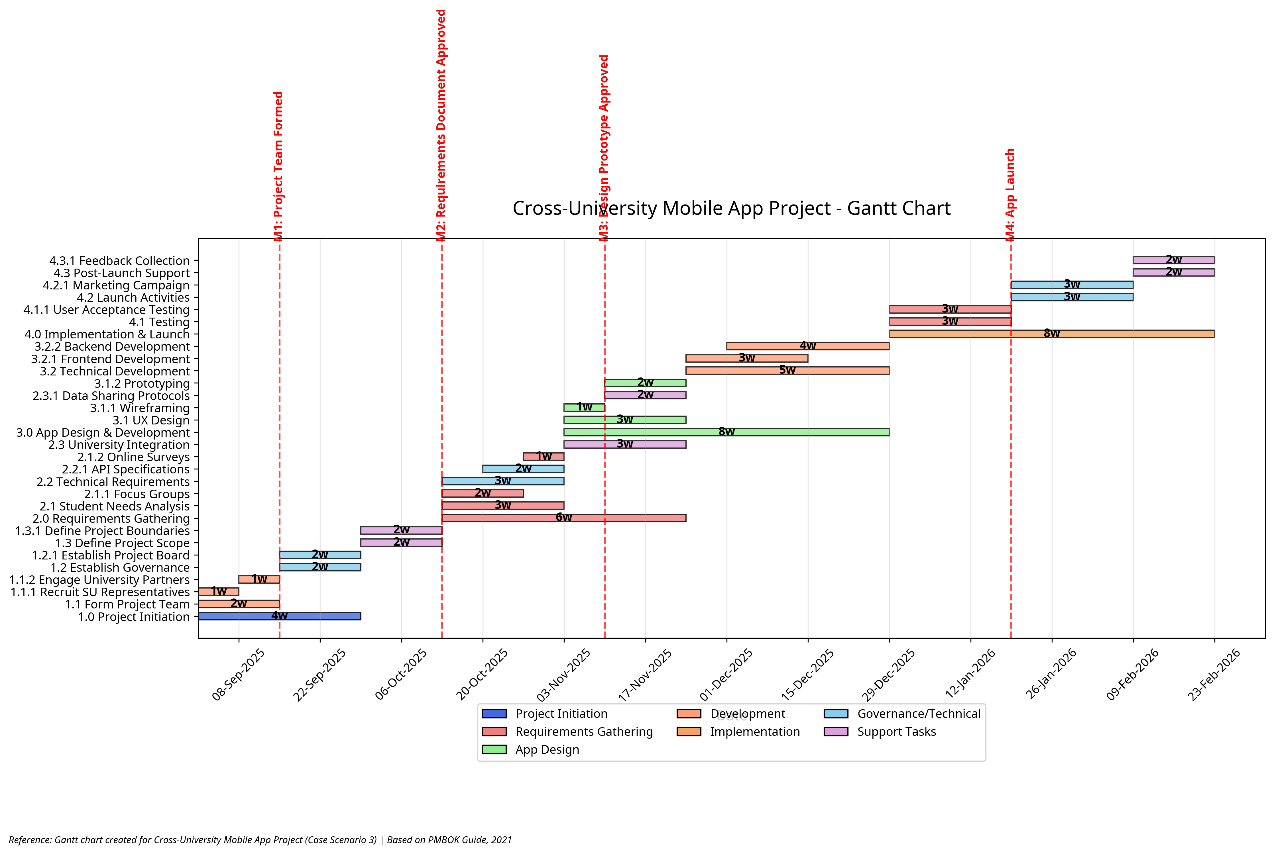
GANTT CHART
The graph does present various tasks such as project initiation, requirements gathering, app design, development and implementation. Government/technical and support tasks are some of the divisions into which the chart divides the tasks. Orange for design, red for development, purple for governance, turquoise for support, green for requirements and blue for initiation are color coded bars that visually distinguish these components. In accordance with a timetable at the charts bottom, each bar shows the time and length of an activity. Vertical dashed lines, such as “First prototype completed” and “app launch approved”, indicate significant project events and deadlines making it easier to see and evaluate progress. This format is essential for tracking the projects development and guaranteeing efficient resource and schedule management.
Project Management
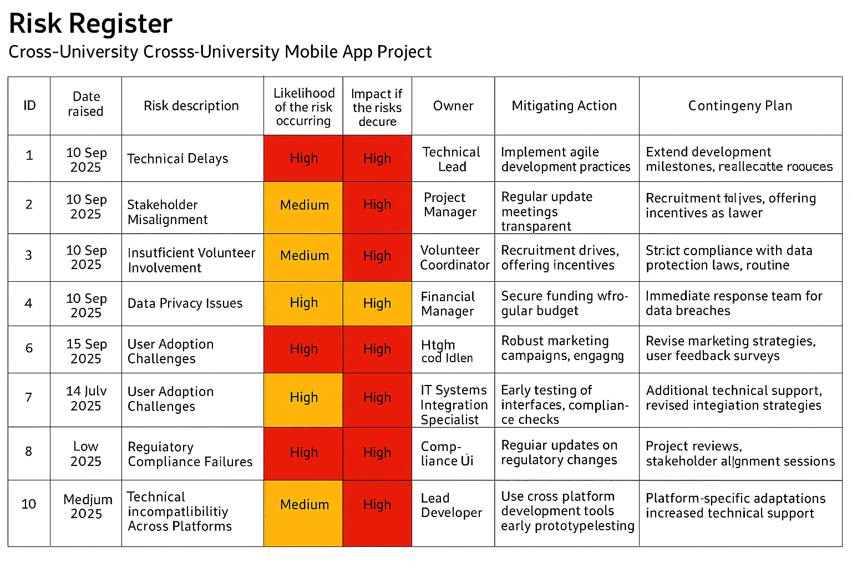
SUGGESTED RISK REGISTER
For our cross-university mobile app project, the risk register is an essential tool since it offers a methodical way to recognize, evaluate, and control possible risks to project success. We can turn uncertainties into controllable elements that can be handled proactively as opposed to reactively by methodically recording risks. The risk register is particularly crucial for this project because of the intricate stakeholder environment that includes numerous universities and outside partners. We can put mitigation plans in place before these risks become real concerns by using the register to assist us spot possible problems early on, such participation difficulties or technical integration issues. Our risk management efforts can be prioritized thanks to the quantitative scoring system, which keeps us informed of lower-priority issues while concentrating resources on high-impact, high-probability hazards. This strategy maximizes the project's chances of success while guaranteeing effective use of our limited resources. The risk register also acts as a communication tool, fostering openness among interested parties regarding possible obstacles and our strategies for resolving them. This openness helps to align expectations across the various universities and partners involved and increases trust in the project management methodology.

Project Management
DISCUSS ROLES AND RESPONSIBILITIES OF PROJECT LEADERSHIP

Project leadership plays a crucial role in determining the success or failure of any project, and this is especially true for our cross-university mobile app initiative. While the sponsor may believe that "anyone can lead and manage projects," this perspective overlooks the unique challenges and specialized skills required for effective project management.
The project sponsor, in our case the Vice Chancellor of Roehampton University, holds a critical position with these key responsibilities:
1. Strategic Direction: Providing high-level vision and ensuring the project aligns with organizational objectives
2. Resource Commitment: Securing necessary resources and institutional support
3. Decision Authority: Making critical decisions, especially when escalated from the project manager
4. Championing the Project: Advocating for the project at executive levels across participating universities
5. Accountability: Ultimately accountable for project success and benefits realization
While the sponsor provides crucial support and oversight, they typically lack the specialized skills and day-to-day involvement required to manage project execution effectively.
The project manager's role is fundamentally different from the sponsor and requires specialized skills:
1. Comprehensive Planning: Developing detailed project plans, schedules, and resource allocations
2. Stakeholder Management: Identifying and managing diverse stakeholders across multiple universities
3. Risk Management: Proactively identifying, assessing, and mitigating project risks
4. Team Leadership: Building and motivating a cross-institutional team of volunteers
5. Communication Management: Ensuring effective information flow among all stakeholders
6. Quality Assurance: Establishing and maintaining quality standards for deliverables
7. Change Management: Controlling scope and managing changes systematically
8. Problem Resolution: Addressing issues promptly to maintain project momentum
9. Progress Monitoring: Tracking progress against plans and taking corrective actions
10. Vendor Management: Coordinating with EE's development team effectively
In the context of our cross-university mobile app project, effective project leadership is particularly critical due to the complex stakeholder environment, technical challenges, and reliance on volunteers from multiple institutions. The project manager must navigate competing priorities, manage expectations across diverse stakeholder groups, and ensure consistent progress despite potential resource constraints.
The success of this project depends on clear role definition and effective collaboration between the sponsor and project manager, with each contributing their unique perspective and expertise while respecting the boundaries of their respective responsibilities.

Project Management
CONCLUSION
The Cross-University Mobile App project represents a significant opportunity to enhance student engagement and foster greater collaboration across London universities. This project management plan has outlined the key components necessary for successful implementation, including a comprehensive Project Initiation Document, detailed Stakeholder Analysis, Power Interest Matrix, and Work Breakdown Structure.
The project faces several challenges that must be carefully managed. First, coordinating efforts across multiple universities with different systems, priorities, and academic calendars will require strong leadership and clear communication channels. Second, ensuring consistent engagement from volunteer representatives will demand thoughtful stakeholder management strategies. Third, balancing technical requirements with user experience needs will necessitate close collaboration between the project team and EE's development team.
Despite these challenges, the project has several factors working in its favor. The sponsorship from EE provides valuable technical expertise and resources without additional cost. The leadership position of Roehampton University, with the Vice Chancellor's support, offers institutional backing and visibility. Additionally, the clear alignment with the National Union of Students' objectives creates potential for future expansion beyond London.
The implementation approach combining elements of Agile and PRINCE2 methodologies provides both the structure needed for multi-institutional coordination and the flexibility required for software development. This hybrid approach will enable the project to maintain governance while adapting to evolving requirements and feedback.
Success will be measured not only by the timely delivery of a functional mobile application but also by its adoption rate among students, the diversity of events and activities featured, and the degree to which it facilitates cross-university interaction. Long-term success will depend on establishing sustainable processes for content management, technical maintenance, and ongoing stakeholder engagement.
By following the frameworks and strategies outlined in this document, the project team will be well-positioned to deliver a valuable tool that enhances the university experience for students across London, with potential for broader impact in the future.

Project Management
BIBLIOGRAPHY
[1] Association for Project Management, APM Body of Knowledge, 7th ed. Buckinghamshire: Association for Project Management, 2019.
[2] Axelos, Managing Successful Projects with PRINCE2, 6th ed. London: The Stationery Office, 2017.
[3] K. Beck et al., "Manifesto for Agile Software Development," 2001. [Online]. Available: https://agilemanifesto.org/. [Accessed: 20-Apr-2025].
[4] "Stakeholder," CIO Wiki, 2020. [Online]. Available: https://cio-wiki.org/wiki/Stakeholder. [Accessed: 20-Apr-2025].
[5] H. Kerzner, Project Management: A Systems Approach to Planning, Scheduling, and Controlling, 13th ed. Hoboken: Wiley, 2022.
[6] "Work Breakdown Structure Templates," Lucid Chart, 2025. [Online]. Available: https://www.lucidchart.com/pages/templates/wbs. [Accessed: 19-Apr-2025].
[7] H. Maylor, Project Management, 4th ed. Harlow: Financial Times Prentice Hall, 2010, pp. 83-138.
[8] National Union of Students, "Digital Strategy 2024-2027," 2024. [Online]. Available: https://www.nus.org.uk/resources/digital-strategy. [Accessed: 19-Apr-2025].
[9] Project Management Institute, A Guide to the Project Management Body of Knowledge (PMBOK Guide), 7th ed. Newtown Square: Project Management Institute, 2021.
[10] K. Schwalbe, IT Project Management, 8th ed. Boston: Cengage Learning, 2015.
[11] K. Schwaber and J. Sutherland, "The Scrum Guide," 2020. [Online]. Available: https://scrumguides.org/. [Accessed: 20-Apr-2025].
[12] "Project Management Templates," Stakeholdermap.com, 2023. [Online]. Available: https://www.stakeholdermap.com/project-templates.html. [Accessed: 18-Apr-2025].
[13] Universities UK, The Future of Student Engagement. London: Universities UK Publications, 2023.
[14] J. Highsmith, Agile Project Management: Creating Innovative Products, 2nd ed. Boston: Addison-Wesley Professional, 2009.
[15] D. West, "Water-Scrum-Fall Is The Reality Of Agile For Most Organizations Today," Forrester Research, 2011.
[16] T. Komus, "Dual Track Agile: Focusing on Customer Value," in Proceedings of the 2020 IEEE International Conference on Engineering, Technology and Innovation, 2020, pp. 1-6.

